Nepal College of Information Technology
Assessment
Spring 2011
Program : BE CE/ELX Time : 3 hrs
Semester : Spring (II) FM : 100
Subject : Applied Mechanics PM : 45

1. a) Explain the concept of particles, rigid body and free body diagram.  b) A Smooth sphere of radius r and weight w hangs by a light string of length l one end of the string is fastened to a point on the surface while other end is fixed to a point on a smooth vertical wall .Determine the reaction of the wall and the tension on the string.  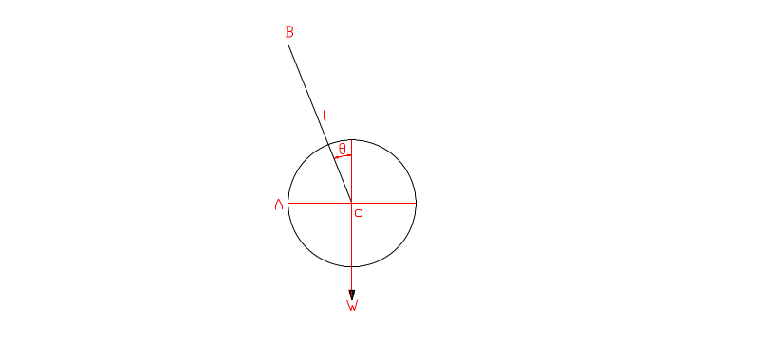  C) A plate measuring 6 m × 4 m is acted upon a set of forces in its plane as shown in figure. Determine  - A force couple system at A  - The perpendicular distance to the resultant force from point A. 8  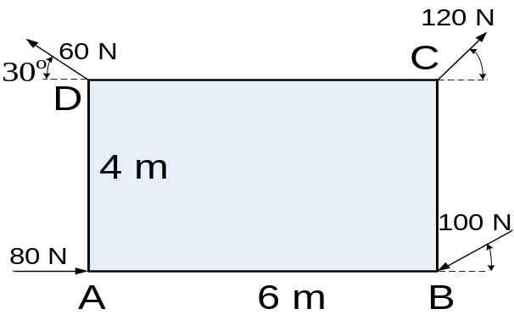 | 3  4

2. a) Determine the Centroid of the Given Shaded area by method of Direct Integration. 8
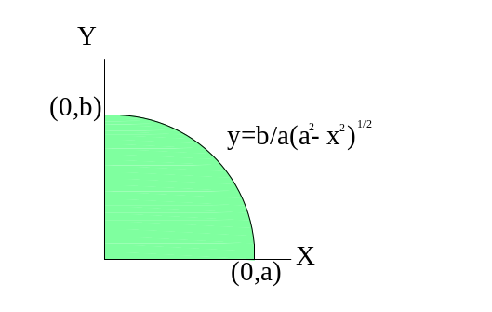

OR
Determined the centroid and moment of inertia of the given shaded composite area.
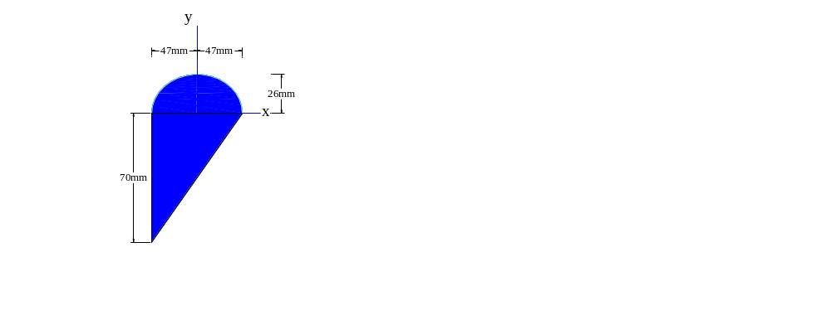
b) Knowing that the coefficient of static friction between the 25 kg block and the incline plane is 0.25.Determine
i) The Smallest value of P required starting the block moving up the incline.
ii) The corresponding value of θ. 7
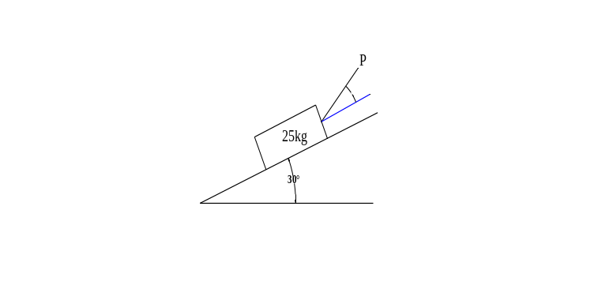
3. a) The Acceleration of the a particle is given by the relation a=-kx at the initial position of velocity is 2m/sec .obtain the position as a function of time when position is 4m and velocity is 0m/sec. 7
b) The motion of the particle is defined by the relation r → =3t²i →+4t^{3→}j+5t^{4→}k where r in meter and t in sec.At the instant when t=4sec find the normal and tangential component of acceleration and the principle radius of curvature. 8
4. a) Two blocks as shown in figure starts from rest. The pulleys are friction less and having no mass the kinetic coefficient of friction between the block A and inclined plane is 0.4.Deyermine the acceleration of each block and tension in each cord. 7
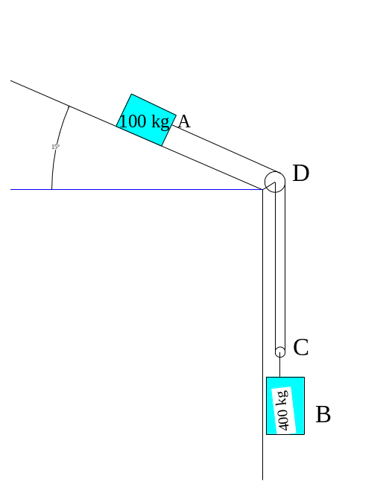
b) The magnitude and direction of the velocities of two identical balls before they strike each are as shown in figure. Assuming e=0.85 determine the magnitude and direction of the velocities of each balls after the impact .How much K.E will be loss due to the impact. 8
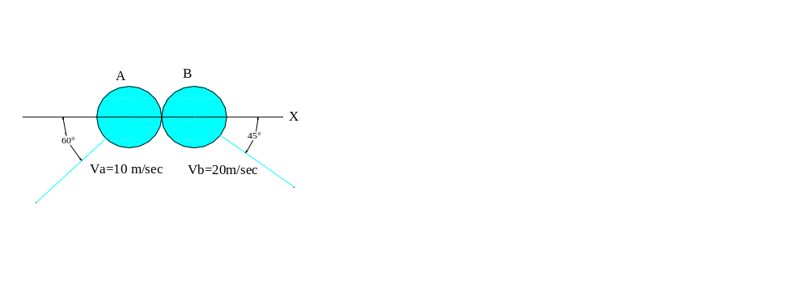
5. a) Obtain the expression for the Kinetic Energy of a system of particles with the concept of centre of Mass . 7
b) Two sphere of 3kg and 4 kg are connected by a spring of outstretched length 0.6m with a modulus of 800 KN/m, move along a smooth plane .At the instant shown in fig a force F→ acts on m₂.find the acceleration of each mass and the acceleration of the centre of mass. 8
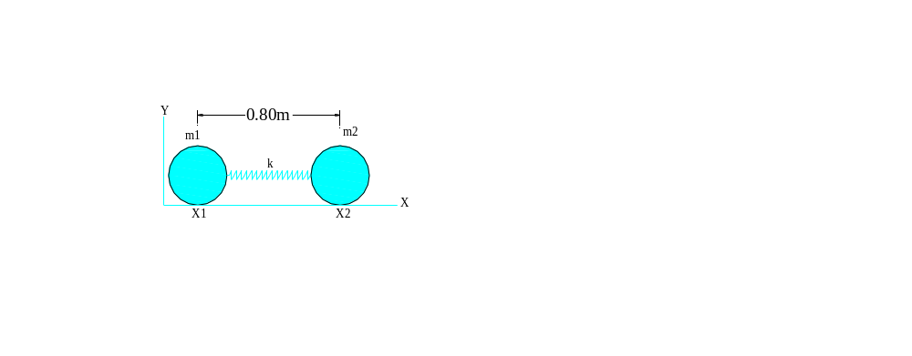
6. a) The end of the rod as shown in figure moves with the constant velocity V_{B} =0.8m/sec .
i) Determine the angular acceleration of the rod.
ii) Velocity and acceleration of the end A. 7
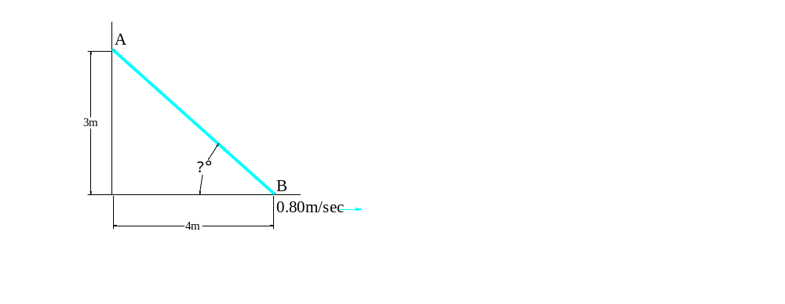
b) What is D-Alembert Principle? Derive the expression for the angular momentum of a rigid body in plane motion. 7
7. Write Short notes on (any two) 10
i) Tangential and Normal Component in curvilinear motion.
ii) Impact
ii) Dynamic Equilibrium
iv) Parallel axis thermo

